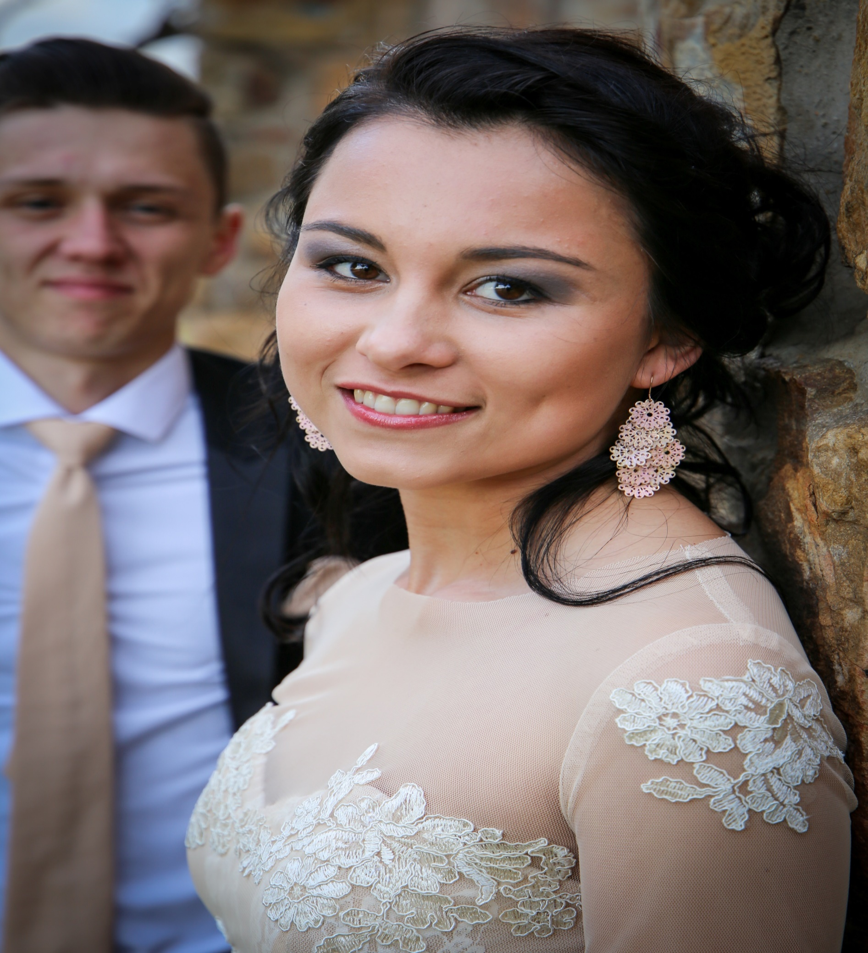

OF SHEREé GREEFF

CURRICULUM VITAE

PERSONAL INFORMATION:

**SURNAME:** Greeff

**NAME:**  Shereé

**POSTAL ADDRESS:** 63A Gillespie Street  
 Uitenhage  
 6229

**HOME ADDRESS:** 63A Gillespie Street  
 Uitenhage   
 6229

**TELEPHONE NUMBER:** 0607979808

**IDENTITY NUMBER:** 9811220027081

**DATE OF BIRTH:** 22 November 1998

**GENDER:**  Female

**MARITAL STATUS:** Single

**NATIONALITY:** South African

**LANGUAGE PROFICIENCY:** Afrikaans

English

**STATE OF HEALTH:** Excellent

**DRIVERS LICENSE:** Code 10

**EMAIL:** [shereegreeff0@gmail.com](mailto:shereegreeff0@gmail.com)

**HOBBIES:** Jogging & drawing

SECONDARY EDUCATION:

**LAST SCHOOL ATTENDED:** Brandwag High School

**HIGHEST GRADE PASSED:** Grade 12

**YEAR:** 2017

**SUBJECTS AND GRADES:** Afrikaans HL  
 English FAL  
 Mathematics  
 Computer Application Tech.  
 Accounting  
 Business Studies   
 Life Orientation

**LEADERSHIP:** Junior Prefect (2014)   
**ACADEMIC ACHIEVEMENT:** Academic Top 10

HIGHER EDUCATION:

**UNIVERSITY ATTENDING:** North-West University

**COURSE:** BSc Information Technology

**PROGRAMMING** Java, C++, C#, Python,

**LANGUAGES:** SQL

**UDEMY COURSES:** HTML, CSS, Javascript

**STUDY PERIOD:** 3 years Full-Time

(Third year – 2020)

WORK EXPERIENCE:

**Matogen:**  Intern

**Ambrosia:** Waitress

**T’s Auto Clinic:** Receptionist

**North-West University:** Casual work

REFERENCES:

Matogen: 081 032 8695  
(Software Development Company)

Tertius Greeff: 076 595 8287 / 041 922 5344  
(Owner of T’s Auto Clinic)

Christopher Stoltz: 073 440 1231 / 041 922 0419  
(Owner of Ambrosia)

Penny: 073 945 3861   
(HR consultant)

Mr. S. Zietsman: 041 922 8188  
(School principal)